 | Verbatim transcription of the video | Comments | Pictures from the video
1  2  3  4  5  6  7  8  9  10  11  12  13  14  15  16  17  18  19  20  21  22  23  24  25  26  27  28  29  30  31  32  33  34  35  36  37  38  39  40  41  42  43  44  45  46  47  48  49  50  51  52  53  54  55  56  57  58  59  60  61  62  63  64  65  66  67  68  69  70  71  72  73  73  74  75  76  77  78  79  80  81  82  83  84  85  86  87  88  89  90  91  92  93  94  95  96  97  98  99  100  101  102  103  104  105  106  107  108  109  110  111  112  113  114  115  116  117  118  119  120  121  122  123  124  125  126  127  128  129  130  131  132  133  134  135  136  137  138  139  140  141  142  143  144  145  146  147  148  149  150  151  152  153  154  155  156  157  158  159  160  161  162  163  164  165  166  167  168  169  170  171  172  173  174  175  176  177  178  179  180  181  182  183  184  185  186  187  188  189  190  191  192  193  194  195  196  197  198  199  200  201  202  203  204  205  206  207  208  209  210  211  212  213  214  215  216  217  218  219  220 | First clip: ~1 min  Stefan: ”Yes...Where were we?”  Trying out a phrase, then turning to the sheet of music to write the phrase down. Apart from tapping his fingers on his legs, Love is passive while Stefan is writing,  Stefan puts the pen on the music stand.  Stefan: ”So the motif so far would be”:  Stefan reads the newly notated phrase on the instrument, and turns to Love  Love: ”mmm” (nodding)  Stefan: ”should we have these last as well?”  Stefan tries to add the last bit to the phrase, plays the longer version.  At the end of the phrase:  - Stefan turns to Love.  - On the last two trills Love turns his left hand and leans forward slightly.  Second clip 1.5 min  Stefan: ”That was actually not too bad.”  Love: no  Stefan plays the two last trills twice and then plays the whole phrase.  At the end of the phrase, at the same trills as before, Love makes the same gesture with the left hand.  Love then sings the end of the phrase again:  - Love: ”Some kind of fermata at...?”  - Stefan plays the trills repeatedly.  - Love sings the phrase.  Stefan: ”On which one?”  Stefan starts the phrase from the beginning.  Stefan: ”Which of them?  Point it out!” Stefan points to the score.  Love leans over and starts pointing in the score:  - Stefan (while playing): ”Aha, several?”  - Love sings and continues to point in the score.  Love again sings a section of the phrase. Stefan plays the beginning of the phrase and stops:  Stefan: ”That one?”  Love: ”Yes”  Stefan tries the opening phrase twice.  Love: ”So that those get quicker.”  Stefan plays the whole phrase and this time makes long fermatas on the two last notes.  Repeats them once and turns to look at Love.  Stefan: ”You can have some real fermatas on those...”  Love: ”what?”  Stefan: ”On these you can have some real fermatas.”  Stefan plays trill and open string right hand tremolo on the last note.  Love: ”Yes, sounds good”  - Stefan starts playing from the beginning of the phrase-  - Love: ”The open (...) 4th string is very helpful.”  Stefan: ”Yes.”  - Stefan starts playing a third time from the beginning of the phrase  - Love: ”The fourth string comes in handy (... ) often.”  Stefan: ”Yes... Yes, exactly!  Actually that’s what I was thinking when we started looking for where to do this bass-motif...”  - Stefan: ”... to find a place where (...) it was idiomatically at hand.”  - Stefan shows on the instrument how the material is disposed on the fretboard and the general action of the left hand in these phrases.  Stefan plays the whole phrase once more. At the end of the phrase Stefan gives Love a glance. Stefan then repeats the two last trills several times.  Third clip 2 min 15 sec  Stefan is writing, leaning closely towards the music stand. Love sits in the couch, arms in his lap.  Stefan: ”...and then you said fermata on this one...”  Love: ”mmm!”  Stefan still writing  Stefan: ”Yes, and...”  - Love leans forward pointing in the score.  - Love: ”What’s good is, eh, when you ... when you sort of... improvise, circling around that one is when you change the emphasis eh... where... kind of...”  - Stefan starts playing the phrase.  - Love: ...”what you stress with the fermatas, where you drag... in the... melody.”  Stefan reaches the last note and expands the fermata with an arpeggiated chord. Stefan gives Love a glance, leaves the chord ringing, waiting for Love’s response.  Love: ”mmm!”  Stefan continues to improvise on the arpeggio.  Stefan looks at Love.  Stefan: ”Good sound.”  - Love: ”Yes. Really!”  - Love changes his position, turning his attention from the music stand to Stefan.  Stefan starts the phrase from the beginning, ending it with the new arpeggio. Tries the end some extra times.  Love: ”That’s not bad at all!”  Stefan looks at Love and then continues the improvisation adding some new material.  Stefan: ”Actually... Yes it’s actually a bit .... in those chords.”  - Showing a chord in the third position to Love.  - Love: ”Yes”  Fourth clip 1 min 20 sec  Stefan: ”...but, this is good and...”  - Stefan starts playing the version mentioned of the melody in harmonics.  - ”...then we have these harmonics...this material too.”  - Love: Notate the last thing you did!  Stefan: This one?  - Starts playing the last arpeggio  - Love: yes  Stefan: This one?  Starts playing the arpeggio repeatedly with the new chords added.  While still playing:  Stefan: ”It’s not so defined.”  - Stefan looks in the sheet of music  - Stefan: ”But... it’s...”  - Love: ”Question is if it needs to be so defined...  question is how you make a notation... to give the feel of it and still let it remain open.”  Stefan let’s the chord ring and says: ”Mmm yes”  - Stefan starts playing again.  - Love: ”Just notate it as a draft...”  Stefan stops playing and says: ”It’s a bit in this thing”:  Plays the phrase and looks back at Love:  ”In the minor seconds... so if you write down these three ... ” Stefan plays the chord. ”...these three note chords...”  Love: ”Yes...exactly...And the harmonics”  Stefan: ”Yes”  - Love points to the score.  - Love: ”Start all the way from that...”  showing the fingering of the chord with his left hand. ”...from that chord.”  Stefan plays the first chord  Love: ”Yes.”  Love leans back in his chair. | Love appears a bit restless, while waiting for Stefan to finish writing.  Stefan turns Love waiting for response or some kind of feedback on the suggested material. However, Love’s response is not very articulate.  He seems not to be very engaged at this moment.  At the moment when Love finds an interpretative line of approach to the material his attitude changes. Towards a more lively and interactive appearance.  The further Love explores his idea of the fermata, the more engaged is his general appearance. He is now interacting with the music.  On the other hand, Stefan doesn’t quite seem to be ready to discuss this interpretative idea as he is still waiting for feedback on the material in itself, so to speak.  Love is suggesting (requesting) a fermata. Stefan, for whom it is not clear where to add the fermata starts playing and asks Love to clarify.  At first Love is not clear of where in the notation the spot is that he is referring to. Therefore he seems to point at several spots in the notation.  At this point the general impression is that of miscommunication inbetween Love and Stefan.  Stefan picks up Love’s idea of fermatas, applying it to the last note of the phrase. He also finds a way to combine right hand tremolo using the open 4th string and lefthand tremolo to get a richer sound on the fermata. After some initial confusion, for the first time Stefan and Love seem to be communicating and working in the same direction.  Love’s remark on the ending fermata can be understood as an attempt on his part to enter the musical and creative discussion.  Although, when Love comments on the instrumental sound and the idiomatic solution, in this spot, Stefan starts playing from the beginning. Stefan then starts to exemplify on the instrument, the general idiomatics of the whole material.  At this moment Love has completely adopted the arbitrary idea of several fermatas, as it appeared, almost by mistake, earlier in the discussion. He is now argumenting for the value of this approach to the material.  At this moment a new idea occurs to Stefan. He looks at Love awaiting his response (not overwhelming at first). The focus now turns from the original variation to this new arpeggio.  Love clearly becomes more interested in what Stefan is actually playing. This is the first time his focus is not on the music stand but on Stefan’s playing the instrument.  Stefan tries to use the new arpeggio as an ending fermata.  After trying this, he adds a chord that Love already had notated for the piece making a new chordal progression, which ends with the new arpeggio.  Stefan tries to sum up the results of the session so far. | 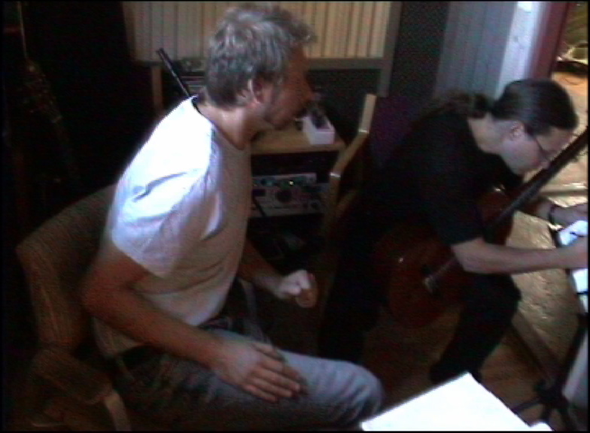  Stefan is writing  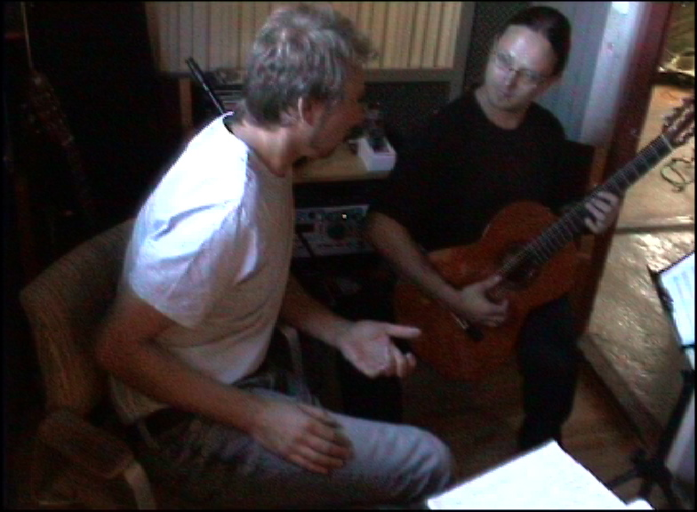  Love turns his left hand and leans forward.  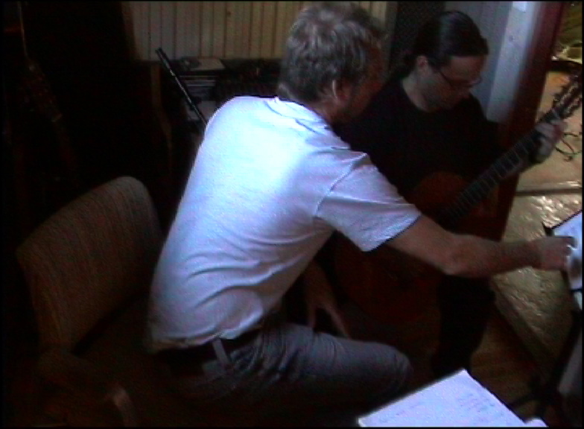  Love leans over and starts pointing in the score.  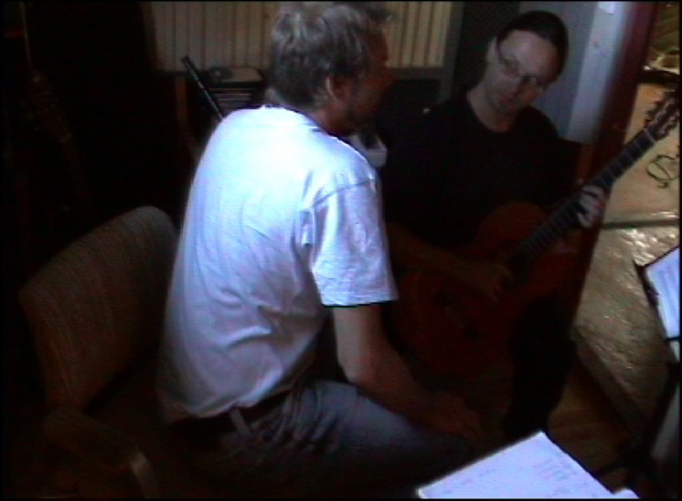  Stefan repeats them once and turns to look at Love.  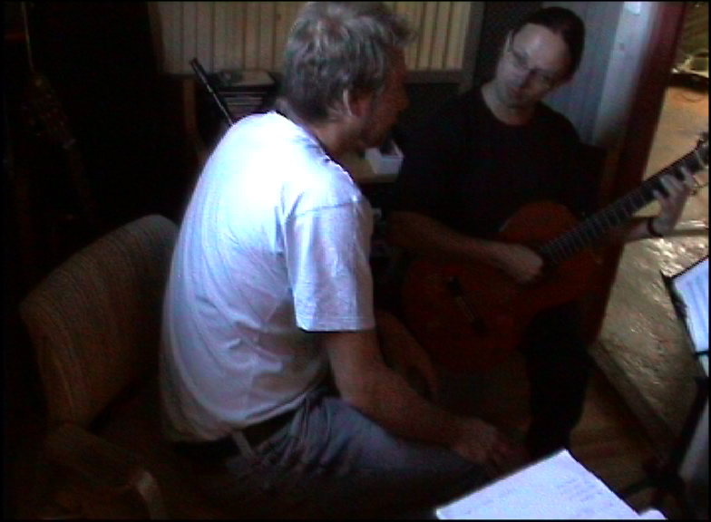  Stefan shows on the instrument how the material is disposed on the fretboard.  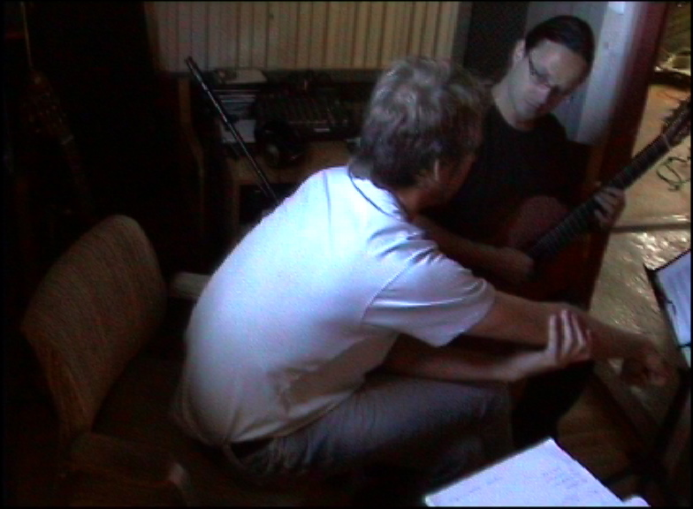  Stefan gives Love a glance, leaves the chord ringing, waiting for Love’s response.  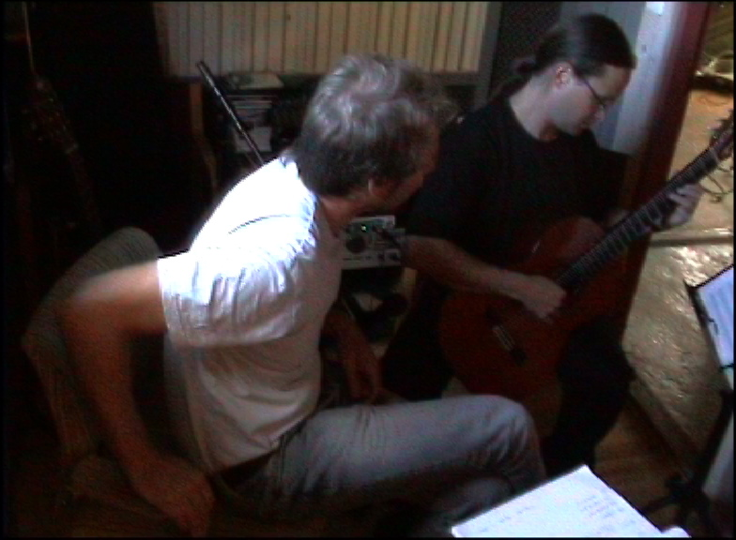  Love changes his position.  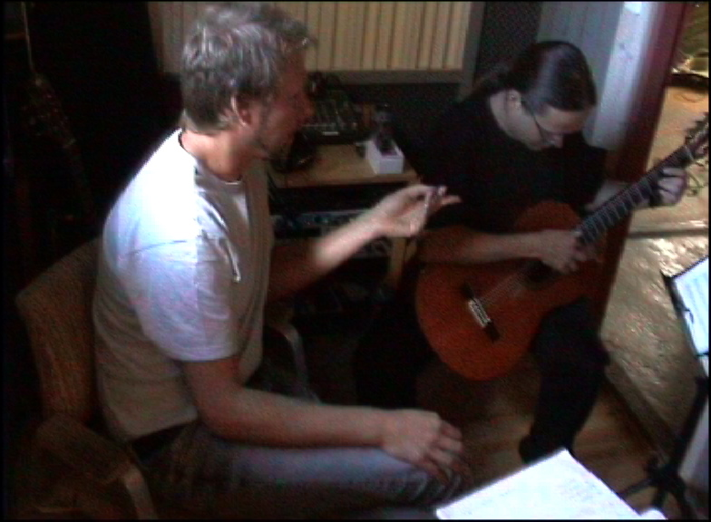  ”Notate the last thing you did.”  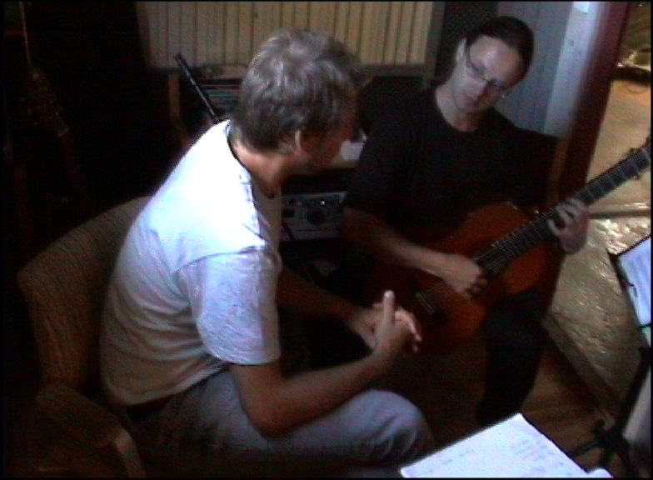  Stefan stops playing and says: ”It’s a bit in this thing”:  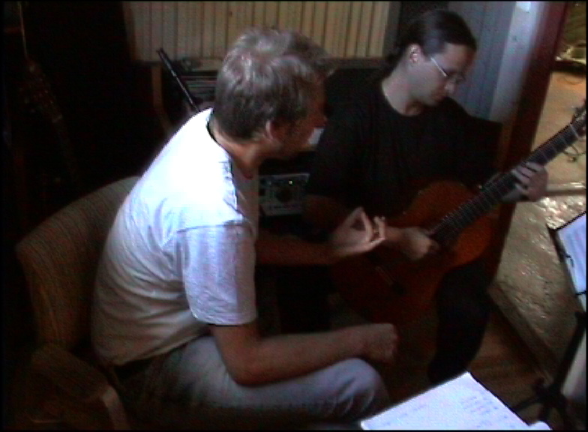  Love shows the fingering of the chord with his left hand.

